Experiment/Practical 8 Support Vector Machine

Title: Implementation of Support Vector Machine (SVM) for Classification
Aim: To implement and understand the Support Vector Machine algorithm for classification tasks and evaluate its performance on a given dataset.
Objective: Students will learn
- The classification mechanism of Support Vector Machines.
- The mathematical formulation and working principle of SVM.
- Implementing SVM for classification tasks using linear and non-linear kernels.
- Evaluating the model's performance using relevant metrics such as accuracy, precision, recall, and F1-score.
- Visualizing decision boundaries in SVM.

Problem statement
Use the given dataset(s) to demonstrate the application of the Support Vector Machine algorithm for classification. The task is to classify the data points into different classes based on features and understand the concept of hyperplanes, margins, and kernel tricks.

Explanation/Stepwise Procedure/ Algorithm:
- Give a brief description of the support vector machine
Support Vector Machine (SVM) is a powerful supervised machine learning algorithm used for classification and regression tasks, but primarily classification. SVM works by finding the optimal hyperplane that best separates different classes in the feature space. It aims to maximize the margin, which is the distance between the hyperplane and the nearest data points from each class, called support vectors.

- Give mathematical formulation (hyperplane, margins)
The hyperplane in SVM is represented mathematically as: where is the normal vector to the hyperplane, is the input feature vector, and is the bias.
Margins are the distances between the hyperplane and the nearest data points. The margin can be expressed as: The optimization goal is to maximize this margin, or equivalently, minimize .
Kernel trick and types of kernel
The kernel trick is used by SVM to handle non-linearly separable data. It transforms input features into a higher-dimensional space, making it easier to find a linear hyperplane. Common types of kernels include:

- Linear kernel
- Polynomial kernel:
- Radial Basis Function (RBF) kernel
- Sigmoid kernel

- Kernel trick and types of kernel

- Write the importance of the support vector machine in the classification task
- Effective in high-dimensional spaces
- Robust against overfitting, especially when the number of dimensions exceeds the number of samples
- Flexible due to kernel functions
- Clearly defined decision boundaries
- Efficient memory usage since only support vectors are needed to define the model

- Mention applications of the support vector machine.
- Image classification and image recognition
- Text categorization and sentiment analysis
- Bioinformatics (e.g., protein classification, cancer diagnosis)
- Handwriting recognition
- Intrusion detection and anomaly detection in cybersecurity
- Credit scoring and risk assessment in finance

- Brief explanation of performance metrics (e.g., accuracy, precision, recall, f1-score, confusion matrix, cross-validation)
Accuracy
Accuracy is the proportion of all classifications that were correct, whether positive or negative. It is mathematically defined as:
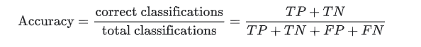

In the spam classification example, accuracy measures the fraction of all emails correctly classified.
Recall, or true positive rate
The true positive rate (TPR), or the proportion of all actual positives that were classified correctly as positives, is also known as recall.
Recall is mathematically defined as:
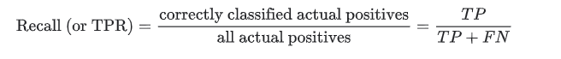
False positive rate
The false positive rate (FPR) is the proportion of all actual negatives that were classified incorrectly as positives, also known as the probability of false alarm. It is mathematically defined as:
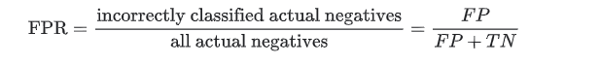
Precision
Precision is the proportion of all the model's positive classifications that are actually positive. It is mathematically defined as:
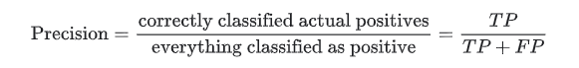

Conclusion:
- Impact of hyperparameters like kernel type, C parameter, and gamma value.
In SVM models, hyperparameters significantly affect performance:
- Kernel type determines the decision boundary shape. Common kernels include linear, polynomial, and RBF (non-linear).
- C parameter controls the trade-off between achieving a low error on the training data and maintaining a smooth decision boundary. A high C tries to fit the training data more precisely, potentially risking overfitting.
- Gamma (used in RBF, polynomial kernels) defines how far the influence of a single training example reaches. Low gamma means far, smooth boundaries; high gamma creates tight boundaries around data points, which may lead to overfitting.

- Comparison of linear vs non-linear SVM models.
- Linear SVM is efficient and works well when data is linearly separable or has many features (like in text classification).
- Non-linear SVM (using kernels like RBF) is better for complex datasets where classes aren’t linearly separable.
- While non-linear models can capture complex patterns, they are more computationally expensive and prone to overfitting if not tuned properly.

